CSA17- ARTIFICIAL INTELLIGENCE
Lab Experiments
1. Write the python program to solve 8-Puzzle problem
Aim
To solve the 8-Puzzle problem using Breadth-First Search (BFS).
Algorithm
- Initialize the start state and goal state.
- Store the start state in a queue.
- Find the blank space (0) and generate possible moves.
- Add unvisited states to the queue.
- Repeat until the goal state is reached.
- Display the solution path and number of moves.
Code:
from collections import deque
# Initial puzzle
start = (1, 2, 3,
4, 0, 6,
7, 5, 8)
# Goal puzzle
goal = (1, 2, 3,
4, 5, 6,
7, 8, 0)
# Possible positions for blank (0)
moves = {
0: [1, 3],
1: [0, 2, 4],
2: [1, 5],
3: [0, 4, 6],
4: [1, 3, 5, 7],
5: [2, 4, 8],
6: [3, 7],
7: [4, 6, 8],
8: [5, 7]
}
def solve(start):
queue = deque([(start, [start])])
visited = {start}
while queue:
state, path = queue.popleft()
if state == goal:
return path
blank = state.index(0)
for pos in moves[blank]:
new_state = list(state)
# Swap blank with next position
new_state[blank], new_state[pos] = \
new_state[pos], new_state[blank]
new_state = tuple(new_state)
if new_state not in visited:
visited.add(new_state)
queue.append((new_state, path + [new_state]))
return None

# Solve puzzle
solution = solve(start)
# Display solution
print("8-Puzzle Solution:\n")
for state in solution:
print(state[0], state[1], state[2])
print(state[3], state[4], state[5])
print(state[6], state[7], state[8])
print()
print("Minimum moves:", len(solution) - 1)

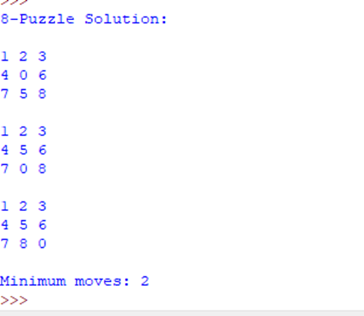
Result
Thus, the 8-Puzzle problem was successfully solved using BFS, and the minimum sequence of moves was obtained.

1. Write the python program to solve 8-Queen problem
Aim
To solve the 8-Queens problem using the Backtracking technique.
Algorithm
- Start from the first row.
- Place a queen in a safe column.
- Check whether the queen conflicts with previous queens.
- If safe, move to the next row.
- If no safe position exists, backtrack.
- Continue until all 8 queens are placed.
Code:
N = 8
board = [-1] * N
def is_safe(row, col):
for i in range(row):
if board[i] == col:
return False
if abs(board[i] - col) == abs(i - row):
return False
return True
def solve(row):
if row == N:
return True
for col in range(N):
if is_safe(row, col):
board[row] = col
if solve(row + 1):
return True
board[row] = -1
return False

# Solve the problem
if solve(0):
print("8-Queens Solution:\n")
for row in range(N):
for col in range(N):
if board[row] == col:
print("Q", end=" ")
else:
print(".", end=" ")
print()
else:
print("No solution exists")
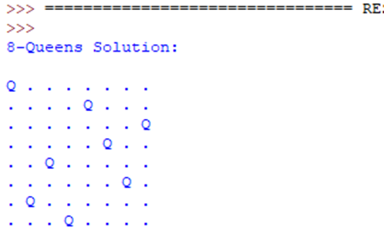
Result
Thus, the 8-Queens problem was successfully solved using Backtracking, obtaining a valid arrangement of 8 queens.

1. Write the python program for Water Jug Problem
Aim
To solve the Water Jug Problem using Breadth-First Search (BFS).
Algorithm
- Start with both jugs empty.
- Generate possible operations: fill, empty, and transfer water.
- Store each state in a queue.
- Avoid already visited states.
- Continue until the required amount of water is obtained.
Code:
from collections import deque
# Jug capacities
A = 4
B = 3
# Initial state
start = (0, 0)
# Goal
goal = 2
def solve():
queue = deque([(start, [])])
visited = set()
while queue:
(a, b), path = queue.popleft()
if (a, b) in visited:
continue
visited.add((a, b))
path = path + [(a, b)]

# Goal reached
if a == goal or b == goal:
return path
states = [
(A, b), # Fill A
(a, B), # Fill B
(0, b), # Empty A
(a, 0), # Empty B
(a - min(a, B-b), b + min(a, B-b)), # A -> B
(a + min(b, A-a), b - min(b, A-a)) # B -> A
]
for state in states:
if state not in visited:
queue.append((state, path))
return None
solution = solve()
print("Water Jug Solution:\n")
for state in solution:
print(state)
print("\nGoal: 2 litres")
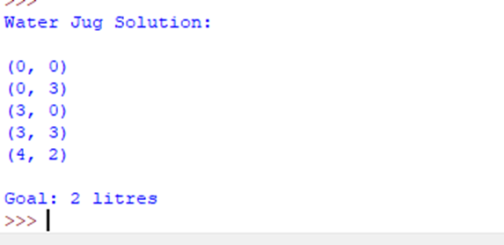
Result
Thus, the Water Jug Problem was successfully solved using BFS, obtaining 2 litres of water.
1. Write the python program for Cript-Arithmetic problem.
Aim
To solve a Crypt-Arithmetic problem using Python by assigning unique digits to letters.
Algorithm
- Assign different digits (0–9) to each letter.
- Ensure the first letters are not zero.
- Form the numerical values of the words.
- Check whether SEND + MORE = MONEY.
- Print the valid assignment.
Code:
from itertools import permutations
# Crypt-Arithmetic: SEND + MORE = MONEY
letters = 'SENDMORY'
for p in permutations(range(10), len(letters)):
S, E, N, D, M, O, R, Y = p
# S and M cannot be zero
if S == 0 or M == 0:
continue

SEND = 1000*S + 100*E + 10*N + D
MORE = 1000*M + 100*O + 10*R + E
MONEY = 10000*M + 1000*O + 100*N + 10*E + Y
if SEND + MORE == MONEY:
print("Solution found:")
print("SEND =", SEND)
print("MORE =", MORE)
print("MONEY =", MONEY)
break
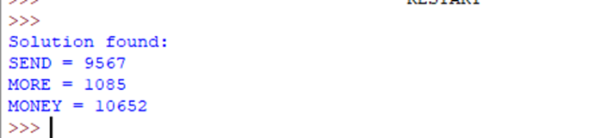
Result
Thus, the Crypt-Arithmetic problem was successfully solved, obtaining:
9567085 = 10652.
5.Write the python program for Missionaries Cannibal problem
Aim
To solve the Missionaries and Cannibals problem using BFS.
Algorithm
- Start with 3 missionaries and 3 cannibals on the left bank.
- Generate possible boat movements.
- Check that missionaries are never outnumbered by cannibals.
- Store unvisited states in a queue.
- Continue until everyone reaches the right bank.
Code:
from collections import deque

start = (3, 3, 0)
goal = (0, 0, 1)
moves = [(1, 0), (2, 0), (0, 1), (0, 2), (1, 1)]
def safe(m, c):
if m < 0 or c < 0 or m > 3 or c > 3:
return False
if m > 0 and m < c:
return False
rm = 3 - m
rc = 3 - c
if rm > 0 and rm < rc:
return False
return True
def solve():
queue = deque([(start, [start])])
visited = {start}
while queue:
state, path = queue.popleft()
m, c, boat = state
if state == goal:
return path
for dm, dc in moves:
if boat == 0:
new_state = (m - dm, c - dc, 1)
else:
new_state = (m + dm, c + dc, 0)
if safe(new_state[0], new_state[1]) and new_state not in visited:
visited.add(new_state)
queue.append((new_state, path + [new_state]))
return None
solution = solve()
print("Missionaries and Cannibals Solution:\n")
for state in solution:
print(state)
print("\n(M, C, Boat)")
print("Boat: 0 = Left, 1 = Right")
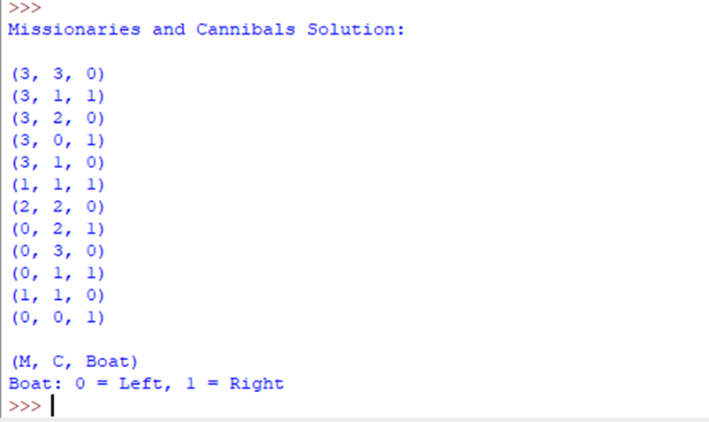
Result
Thus, the Missionaries and Cannibals problem was successfully solved using BFS.

6.Write the python program for Vacuum Cleaner problem
Aim
To solve the Vacuum Cleaner Problem using BFS.
Algorithm
- Start with both rooms dirty.
- Check the current room.
- Clean the room if it is dirty.
- Move the vacuum to the other room.
- Repeat until both rooms are clean.
Code:
from collections import deque
start = ('A', 1, 1)
goal = ('A', 0, 0)
def solve():
queue = deque([(start, [start])])
visited = {start}
while queue:
state, path = queue.popleft()
position, left, right = state
if left == 0 and right == 0:
return path
if position == 'A' and left == 1:
new_state = ('A', 0, right)
elif position == 'B' and right == 1:
new_state = ('B', left, 0)
else:
new_state = None
if new_state and new_state not in visited:
visited.add(new_state)
queue.append((new_state, path + [new_state]))
if position == 'A':
new_state = ('B', left, right)
else:
new_state = ('A', left, right)
if new_state not in visited:
visited.add(new_state)
queue.append((new_state, path + [new_state]))
return None
solution = solve()
print("Vacuum Cleaner Solution:\n")
for state in solution:
print(state)
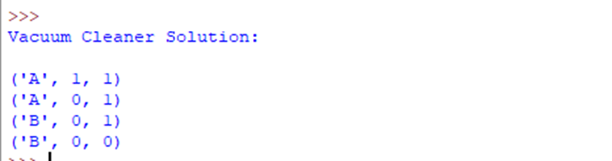

Result
Thus, the Vacuum Cleaner Problem was successfully solved using BFS, and both rooms were cleaned.
7.Write the python program to implement BFS.
Aim
To implement Breadth-First Search (BFS) for traversing a graph.
Algorithm
- Start from the given node.
- Add the node to the queue.
- Remove a node from the front of the queue.
- Visit its unvisited adjacent nodes and add them to the queue.
- Repeat until the queue is empty.
Code:
from collections import deque
graph = {
'A': ['B', 'C'],
'B': ['D', 'E'],
'C': ['F'],
'D': [],
'E': [],
'F': []
}
start = 'A'
queue = deque([start])
visited = set()
print("BFS Traversal:")
while queue:
node = queue.popleft()
if node not in visited:
print(node, end=" ")
visited.add(node)
for neighbour in graph[node]:
if neighbour not in visited:
queue.append(neighbour)
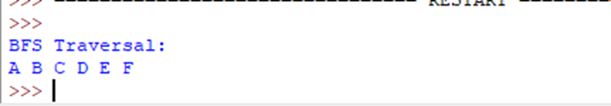
Result
Thus, BFS graph traversal was successfully implemented and the nodes were visited level by level.
8.Write the python program to implement DFS.
Aim
To implement Depth-First Search (DFS) for traversing a graph.
Algorithm
- Start from the given node.
- Mark the node as visited.
- Visit an unvisited adjacent node.
- Continue recursively until no unvisited node remains.
- Backtrack and visit remaining nodes.
Code:
graph = {
'A': ['B', 'C'],
'B': ['D', 'E'],
'C': ['F'],
'D': [],
'E': [],
'F': []
}
visited = set()
def DFS(node):
visited.add(node)
print(node, end=" ")

for neighbour in graph[node]:
if neighbour not in visited:
DFS(neighbour)
print("DFS Traversal:")
DFS('A')
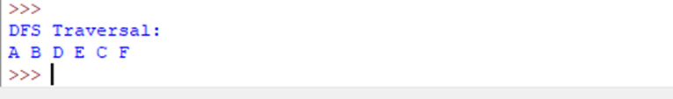
Result
Thus, DFS graph traversal was successfully implemented, and the nodes were visited depth-wise.
9.Write the python to implement Travelling Salesman Problem
Aim
To implement the Travelling Salesman Problem (TSP) using the Brute Force method.
Algorithm
- Store the distances between cities.
- Generate all possible routes.
- Calculate the cost of each route.
- Compare all route costs.
- Select the route with minimum cost.
Code:
from itertools import permutations
distance = [
[0, 10, 15, 20],
[10, 0, 35, 25],
[15, 35, 0, 30],
[20, 25, 30, 0]
]
n = len(distance)
cities = range(1, n)
min_cost = float('inf')
best_path = None
for path in permutations(cities):
route = (0,) + path + (0)
cost = 0
for i in range(len(route) - 1):
cost += distance[route[i]][route[i + 1]]
if cost < min_cost:
min_cost = cost
best_path = route
print("Best Route:", end=" ")
for city in best_path:
print(city, end=" ")
print("\nMinimum Cost:", min_cost)
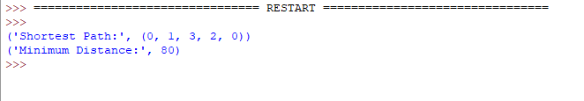

Result
Thus, the Travelling Salesman Problem was successfully implemented, and the minimum-cost route was obtained.
10.Write the python program to implement A* algorithm
Aim
To implement the A* search algorithm to find the shortest path between two nodes.
Algorithm
- Start with the initial node.
- Calculate f(n) = g(n) + h(n).
- Select the node with the lowest f(n).
- Expand its neighboring nodes and calculate their costs.
- Repeat until the goal node is reached.
- Display the shortest path and its cost.
Code:
import heapq
graph = {
'A': [('B', 1), ('C', 4)],
'B': [('D', 2), ('E', 5)],
'C': [('E', 1)],
'D': [('G', 3)],
'E': [('G', 2)],
'G': []
}
h = {
'A': 7,
'B': 6,
'C': 4,
'D': 3,
'E': 2,
'G': 0
}
def astar(start, goal):
queue = [(h[start], 0, start, [start])]
visited = set()

while queue:
f, cost, node, path = heapq.heappop(queue)
if node == goal:
return path, cost
if node in visited:
continue
visited.add(node)
for neighbour, edge_cost in graph[node]:
new_cost = cost + edge_cost
f = new_cost + h[neighbour]
heapq.heappush(
queue,
(f, new_cost, neighbour, path + [neighbour])
)
return None, None
start = 'A'
goal = 'G'
path, cost = astar(start, goal)
print("A* Algorithm")
print("Path:", " -> ".join(path))
print("Cost:", cost)
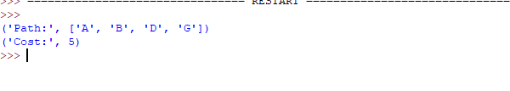
Result
Thus, the A* algorithm was successfully implemented and the shortest path from A to G was found.

